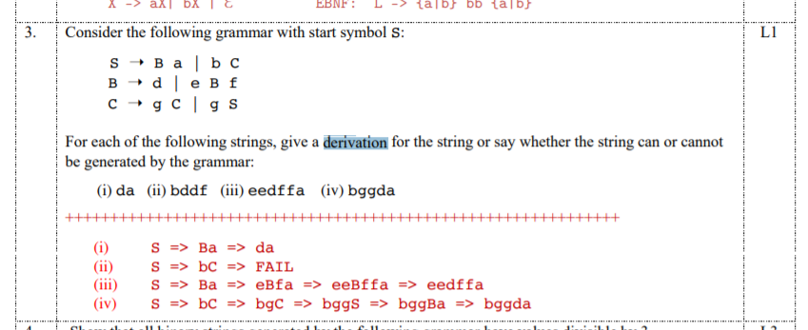

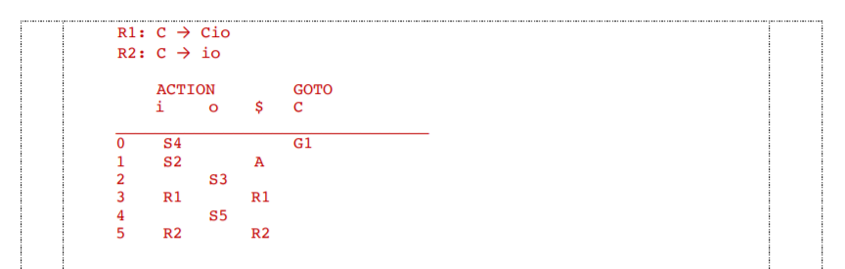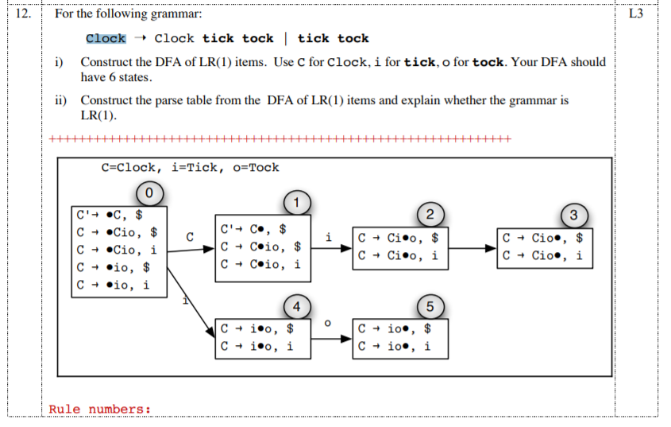

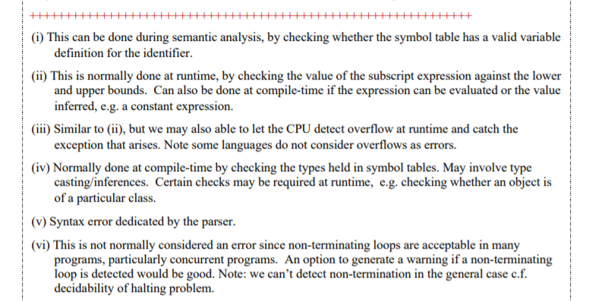



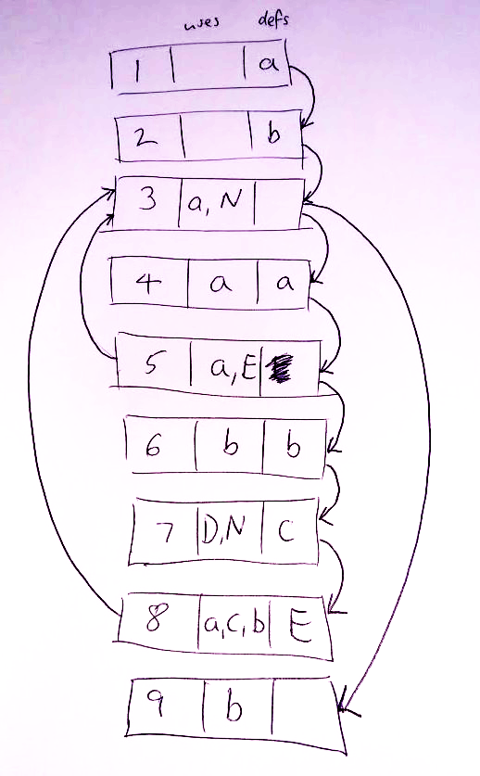

* 1. {4,5,6,7,8}
  2. a
  3. {3,4j,5}, {3,4,5,6,7,8}
  4. S8 : {4,6,7}

S9 : {2,6}

* 1. Yes, since it satisfies all the 4 four req,,,,,uirements (should probably write them out & explain)